6/27/2019

Kyer Potts

30003389

Interface Design AT2

Interface Report

Table of Contents

Introduction 1

Colour Scheme 2

Navigation 3

UI Testing 4

Sign-Off 10

# Introduction

The UI for this database allows the user to save and edit the data of tables containing information about various bands, musicians and their respective shows, instruments and skills. A series of forms and menus have been created to facilitate the process of adding or editing information within their respective tables. These forms have been designed with an ease of use philosophy, with simple labelling and navigation mechanics that will allow users of all skill levels to autonomously engage with the database.

# Colour Scheme

The UI for this database has implemented a white, lime green and grey blue colour scheme. This scheme was used to maintain readability and provide and “easy on the eyes” interface.

The background of all forms is a simple stock white. This allows all information displayed within the forms to maintain readability. Simplicity and ease of use is the primary goal of this UI.

The header background and header text use two variations of a neutral grey blue colour. This allows the header to stand out from other information displayed within the form and improves the ease of navigation throughout the various forms.

All buttons located throughout the forms and menus are a bright lime green with automatic black font. This was chosen to give the forms some life and contrast with the neutral colours of the background and form headers. It also serves to create a distinction between navigation buttons and other information displayed on the forms and menus, once again reinforcing the UI design philosophy of simplistic ease of use.

# Navigation

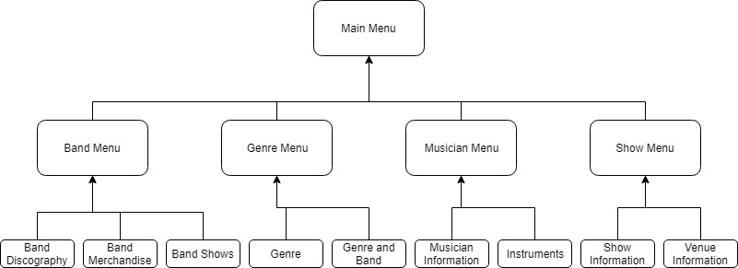

Form navigation has been designed around the categorisation of various tables and the data that their respective forms display. The main menu features as a starting and return point for all of the submenus and forms. It contains 4 buttons which direct the user to separately defined menus. These are; the Band Menu, the Genre Menu, the Musician Menu, the Show Menu. These submenus contain the buttons that will direct the user to the appropriate form depending on their needs. All forms can be accessed through the menu navigation systems.

Each form also has a help button included in the top right corner, to assist the user with form and record navigation.

To print the show report, navigate through the Band Menu to the Band Shows forms. There is a “Print Report” button located in the top right corner of the form that will allow the user to generate a report of all of the show information.

# UI Testing

|  |  |  |  |
| --- | --- | --- | --- |
| Case ID | Description | Outcome | Screenshot |
| 1. | Main Menu | Main Menu displays the four submenu buttons, each button open the appropriate submenu |  |
| 2. | Main Menu Help Button | The help button directs the user to help information relevant to the menu and submenu system |  |
| 3.1 | Band Menu Button | Band Menu button directs the user to the Band Menu Submenu |  |
| 3.2 | Band Discography Button | Directs the User to the Band Discography Form |  |
| 3.3 | Band Merchandise Button | Directs the User to the Band Merchandise form |  |
| 3.4 | Band Shows Button | Directs the User to the Band Shows form |  |
| 3.5 | Band Menu Help Button | Directs the user to the menu Help form |  |
| 4.1 | Genre Menu Button | Directs the user to the Genre submenu |  |
| 4.2 | Genre Button | Directs the user to the Genre form |  |
| 4.3 | Genre and Band Button | Directs the user to the Band and Genre form |  |
| 4.4 | Genre Menu Help Button | Directs the user to the menu Help form |  |
| 5.1 | Musician Menu Button | Directs the user to the Musician submenu |  |
| 5.2 | Musician Information Button | Directs the user to the Musician Information Form |  |
| 5.3 | Instruments Button | Directs the user to the Instruments form |  |
| 5.4 | Musician Menu Help Button | Directs the user to the menu help form |  |
| 6.1 | Show Menu Button | Directs the user to the Show submenu |  |
| 6.2 | Show Information Button | Directs the user to the Show Information form |  |
| 6.3 | Venue Information Button | Directs the user to the Venue Information form |  |
|  | Show Menu help Button | Directs the user to the help menu form |  |
| 7. | Form help Button | Directs the user to the record help form from any table driven form |  |
| 8. | Print Button | Prints a report of shows. Located on the Band Shows form |  |

# Sign-Off

USER INTERFACE ACCEPTANCE SIGN-OFF FORM

For Project: AT2 Project 2019

Submitted for testing on: 27/06/2019

Test Team Leader: Kyer Potts

**Item Tested** On: 27/06/2019

* Main Menu Navigation
* Sub Menu Navigation
* Close Buttons
* Back Buttons
* Minor Data Entry (single table)
* Major Data Entry (multi-table)
* Report
* Help Files

**Proof of Compliance:**

User Acceptance Checklist completed

Test results attached

**Sign-Off Section:**

This system conforms to agreed specifications.

_________________________________ ____________

Signature of Executive Date

_______________________________________________________

Name/Position